Machine Learning Engineer Nanodegree
Capstone Proposal
Lee XA
September 2017

Proposal : Modeling RNA structural interactions with deep learning
Contents
1. Domain Background
2. Problem Statement
3. Datasets and Inputs
4. Solution Statement
5. Benchmark Model
6. Evaluation Metric
7. Project Design
8. References
9. Appendix

1. Domain Background (Biochemistry)
All biology depends on nucleotide and amino acid sequences which spontaneously fold to form 3D atomic biochemical structures, with the former relatively less studied. (Wan et al. 2011). However, RNA structure has increasingly been found to play a significant role in regulating cellular activities where two examples include RNA polymerase, riboswitches whose function is to make a RNA copy of DNA and sense metabolic molecules respectively (Wan et al. 2011). As RNA and associated molecules bind specifically through complementary shapes and energetically favorable interactions (Van der Waals interaction, hydrogen bonds, ionic pairing) (Lounnas et al. 2013), there is a need to study RNA structure. The primary depository of structural data is the Protein Data Bank (https://www.rcsb.org/pdb/home/home.do).

Among the 100 thousand structures deposited into the Protein Data Bank, only three thousand contains RNA -- RNA is inherently flexible and difficult to resolve to a good resolution (Ke 2004). There is now a need to develop of various computational tools to predict RNA tertiary structure, where notable developments include statistical mechanics and machine translation methods (Das and Baker 2007; Popenda et al. 2012). It must be noted that RNA contains at least 20 *length atoms and the 3D space to explore when predicting an RNA structure is not a trivial task. We know much more about proteins yet the folding problem remains unsolved, and this applies even more to RNA folding where structural prediction is needed to predict structures too difficult to experimentally resolve (Dev 2015).

One area at least to my knowledge not attempted is deep learning, despite having successfully applied to a similar class of biological molecules – proteins which are largely analogous to RNA in structure and function (Wang et al. 2017). It is hoped that deep learning can be used to help predict RNA structure or least reduce the complexity of RNA structure problem for other algorithms.

2. Problem Statement
I will be predicting pair-wise atom euclidean distances between basic building blocks of RNA, also called residues shown in MATRIX D (refer to formula 1). The matrix is zero-diagonal symmetric. The matrix has dimensions n * n , with n being number of residues in RNA sequence in the pair-wise distance matrix D.

Figure 1a shows exactly what we are measuring, which is the distance between two RNA phosphate atoms, while figure 1b shows an entire RNA structure with 70 residues and a complex fold for you to gain an intuition of the complexity of the problem.

To be specific about matrix D, since distance based regression may be difficult, I would predict three categorical values instead of actual euclidean distances. The other reason why I used distance categorical values is that I would be able to assign probabilities on the predictions. These distance categories are short, medium and long which are <8Å , 8-15Å and >15 Å respectively. 1Å is a unit of measurement of the field, which equals 10⁻¹⁰m. The distance matrix hence is a tensor of size (Length * Length * 3 categories).

Formula 1

Figure 1a,b : A). Two RNA residues and the distance between phosphate atoms shown in red spheres. B). Example of RNA molecule and its complex structural fold (2cky).
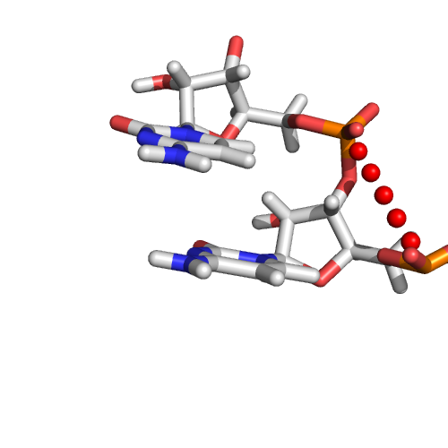A
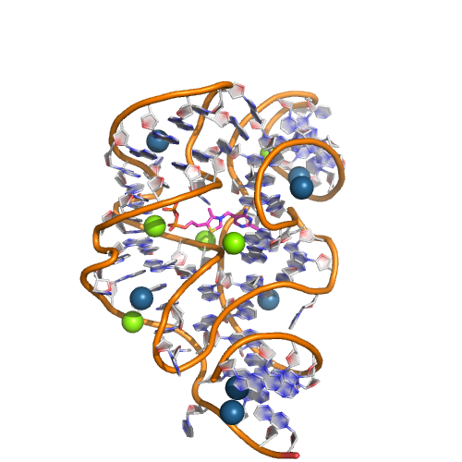B

3. Datasets and Inputs
The dataset used here will be RNA structures solved through experimental means from the Protein Data Bank. All of these structures contain the 3D ordinates for the atoms and the residue sequence. The input variable will be the RNA sequence one-hot encoded and related features (formula 2), while the output variable will be the pairwise distance matrix D.

RNA sequences contain of only four difference building blocks, A, U, G and C, and a sequence of AUGCGG will have an input of the matrix below sized Number_of_features * length (formula 2). There will also be pair-wise inputs of size (length * length) which will be appropriately merged into the model (refer to section 7). Furthermore, I will include extra features determined by feature engineering using open source bioinformatics software. One tool I will use is a software suite ViennaRNA (Lorenz et al. 2011).

Formula 2 for AUGCGG

There are a total of 490 structures in the train dataset, with RNAs from 35-500 residues long. This number is much reduced compared to total structures due to redundancies in the protein data bank as each structure may occur multiple times in variations not applicable for our project. We used a manually curated list of non-redundant structures found here of version 2.141 to ensure our data is unbiased. The data will be augmented by subsampling 35, 50, 75, 100, 150, 200, 400, 600, 800 residues of the entire structure. An example will be a structure of 900 residues long. I will take subsamples of 35 residues, 75 residues,….. and so on. This will increase the size of the train data by a hundred times.

Unfortunately you are not a biochemist and thus you have to assume that the data I propose is most suitable given the problem. The input data is of dimensions (Num_of_features * Length) and (Length * Length * Num_of_features) and output variable is (Length * Length * 3).

I have included an example how to navigate the database site in the appendix.
4. Solution Statement
It is useful to note that the distance matrix D is very similar to an image and I will use CNN to solve the problem with a notable difference that pixel level regression will be done. This might pose some difficulties, but hey if the problem was so simple, it should be trashed.

Why I believe a CNN is suitable is that filters are invariant to input lengths. RNA differ in orders of magnitude in length, and CNN can handle such inputs. Furthermore, certain sequence patterns of RNA are correlated with certain geometries, and this can be picked up through convolution filters and proceed to predict through the distance matrix D.

A suitable architecture is below.
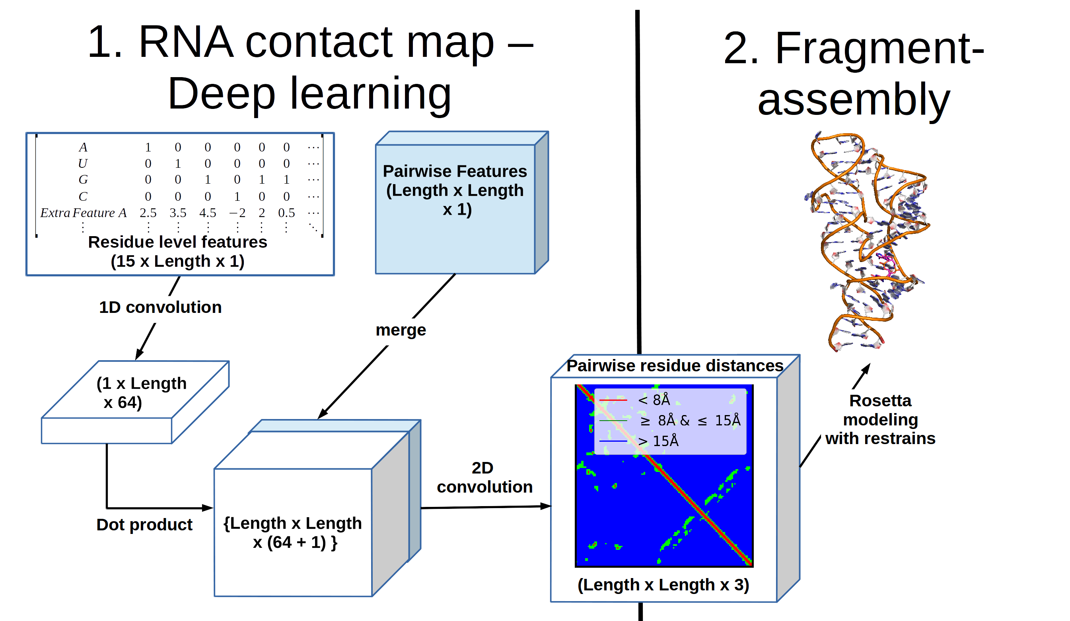
Figure 2 Architecture of work flow : Machine Learning portion only consist of part 1, part 2 is outside the scope of the project.

5. Benchmark Model
I will use 15 RNA structures from previous RNA modeling competition also called RNA puzzles (http://ahsoka.u-strasbg.fr/rnapuzzlesv2/) . I wish to see how well the method does compared to other state of the art methods used in these competitions. The test set contains relatively few structures and this is a limitation of the field since RNA structure determination is extremely challenging and could take years. I will also explicitly remove these 15 structures from the train set.

There are many different types of RNA modeling tools, however these tools have likely already been trained on the entire train dataset, making it not a blind accuracy test. Thus a retrospective analysis RNA competitions are most suitable comparisons for accuracy. Furthermore, these competitions use current state of the art tools.

It is useful to note that RNA puzzles predicts the entire structure while I only predict pair-wise distances categories. To ensure a fair comparison, I will extract the distance matrix from RNA-puzzles for comparison to my deep learning model. The modeling of the entire structure is outside the scope of the project as shown in part 2 (Figure 2a) and does not involve machine learning.

6. Evaluation metric
I will be evaluating predictions eg. Short, medium or large using a weighted accuracy metric. This is because the ratio of short,medium to large distances are in ratio of 0.04, 0.06 and 0.9 respectively and skewed towards larger distances. The weights for the short,medium and large distances are k/0.04, k/0.06 and k/0.9 where k is a normalizing constant to ensure sum of weights equal to 1. A weighted categorical log-loss using the weighted logits will be used to optimize the model.

7. Project Design
The first thing to be done is to download all non-redundant structures, followed by using a variety of python scripts to extract the necessary information. An example of the data is shown in appendix.

Given that the sequence length varies, CNN networks are most suitable as they can : i) handle inputs of different lengths, ii) are able to capture local information of sequences which is important since local environment plays a role in RNA structure, iii) able to model complex interactions too complex for humans to dissect, iv) shown to work for a related class of biological molecules – proteins.

The raw inputs are sequence, and the rich variety of open source bioinformatics software will be used to give more inputs to the model. Thus the CNN model will receive these three classes of inputs : i) Sequence, ii) single residue features and iii) pairwise residue features. Features i and ii will undergo an outer product operation to become length * length matrix before merging with feature iii. These merge layer would then undergo a deep CNN before outputting the D distance matrix.

For the CNN, I will first try a simple architecture, changing these hyper parameters : I) convolution filter size, ii) number of hidden layers iii) number of filters of each layer. Cross-validation will be used to get the optimal hyper parameters.

One limitation of the study is the small training size and the diversity of RNA structures. This is a limitation of the field, but it is hoped with data augmentation we will be able to generalize RNA structure.
8. References
Das, Rhiju, and David Baker. 2007. “Automated de Novo Prediction of Native-like RNA Tertiary Structures.” Proceedings of the National Academy of Sciences 104 (37): 14664–14669.
Dev, Sukhendu B. 2015. “Unsolved Problems in biology—The State of Current Thinking.” Progress in Biophysics and Molecular Biology 117 (2–3): 232–39. doi:10.1016/j.pbiomolbio.2015.02.001.
Ke, A. 2004. “Crystallization of RNA and RNA?protein Complexes.” Methods 34 (3): 408–14. doi:10.1016/j.ymeth.2004.03.027.
Lorenz, Ronny, Stephan H. Bernhart, Christian Hoener Zu Siederdissen, Hakim Tafer, Christoph Flamm, Peter F. Stadler, and Ivo L. Hofacker. 2011. “ViennaRNA Package 2.0.” Algorithms for Molecular Biology 6 (1): 26.
Lounnas, Valère, Tina Ritschel, Jan Kelder, Ross McGuire, Robert P. Bywater, and Nicolas Foloppe. 2013. “CURRENT PROGRESS IN STRUCTURE-BASED RATIONAL DRUG DESIGN MARKS A NEW MINDSET IN DRUG DISCOVERY.” Computational and Structural Biotechnology Journal 5 (6): 1–14. doi:10.5936/csbj.201302011.
Popenda, M., M. Szachniuk, M. Antczak, K. J. Purzycka, P. Lukasiak, N. Bartol, J. Blazewicz, and R. W. Adamiak. 2012. “Automated 3D Structure Composition for Large RNAs.” Nucleic Acids Research 40 (14): e112–e112. doi:10.1093/nar/gks339.
Wan, Yue, Michael Kertesz, Robert C. Spitale, Eran Segal, and Howard Y. Chang. 2011. “Understanding the Transcriptome through RNA Structure.” Nature Reviews Genetics 12 (9): 641–55. doi:10.1038/nrg3049.
Wang, Sheng, Siqi Sun, Zhen Li, Renyu Zhang, and Jinbo Xu. 2017. “Accurate de Novo Prediction of Protein Contact Map by Ultra-Deep Learning Model.” PLoS Computational Biology 13 (1): e1005324.
9. Appendix
I have provided a an example of a data source below : HIV-1 TAR RNA molecule in complex with a drug (Neomycin B).

Webpage with RNA : http://www.rcsb.org/pdb/explore/explore.do?structureId=1QD3
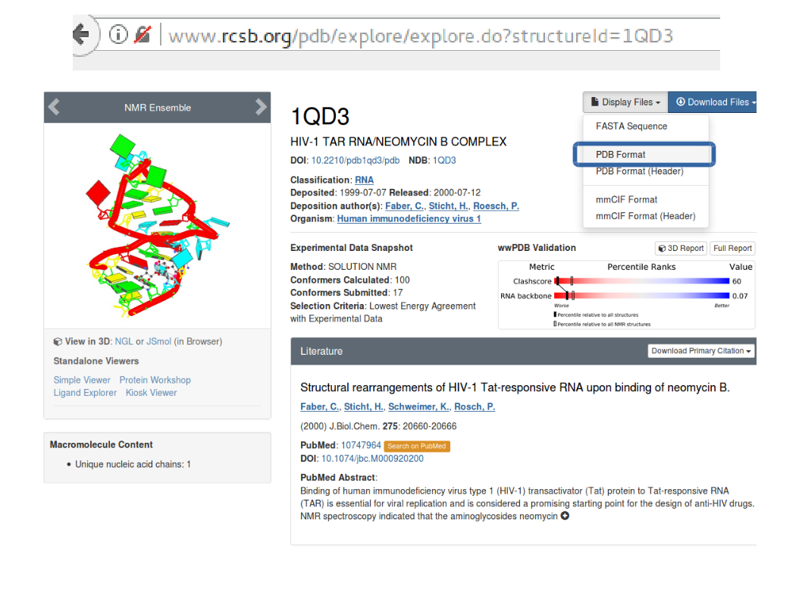
After clicking PDB format, you see a file with gibberish unless you have a PHD in x-ray crystallography. Ignore the gibberish and proceed to lines with the word ATOM. Columns to pay attention are 13-16, 18-20, 21, 23-26, 31-54. These respectively gives atom type, residue type, chain, residue number and xyz coordinates. I will need these information to identify the phosphate atom of each residue and its coordinates.

### SAMPLE OF PAGE ###
ATOM 32 P C A 18 -9.580 -0.134 -9.860 1.00 0.30 P
ATOM 33 OP1 C A 18 -11.026 0.169 -9.719 1.00 0.38 O
ATOM 34 OP2 C A 18 -8.610 0.453 -8.900 1.00 0.35 O
ATOM 35 O5' C A 18 -9.405 -1.717 -9.844 1.00 0.27 O
##### End of Sample #####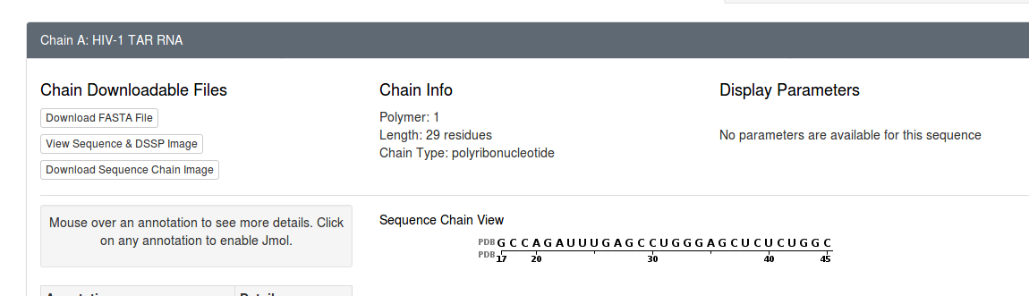
The sequence of the structure is recorded above. Do note that this example was not in the training set because it is shorter than 35 residues long.

